1. NOTE: The title for this lecture is “Comparison of Maps” but here we’re talking about Set.   
   This is because Set and Map both are same.  
   See lecture# 58, where the same has been explained related to map. If you know that one, you know about this lecture too as   
   HashSet, LinkedHashSet and TreeSet are same as HashMap, LinkedHashMap and TreeMap.
2. 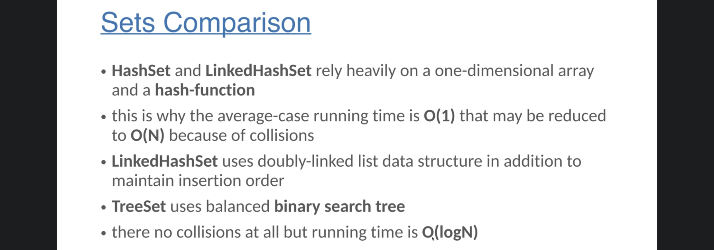
3. 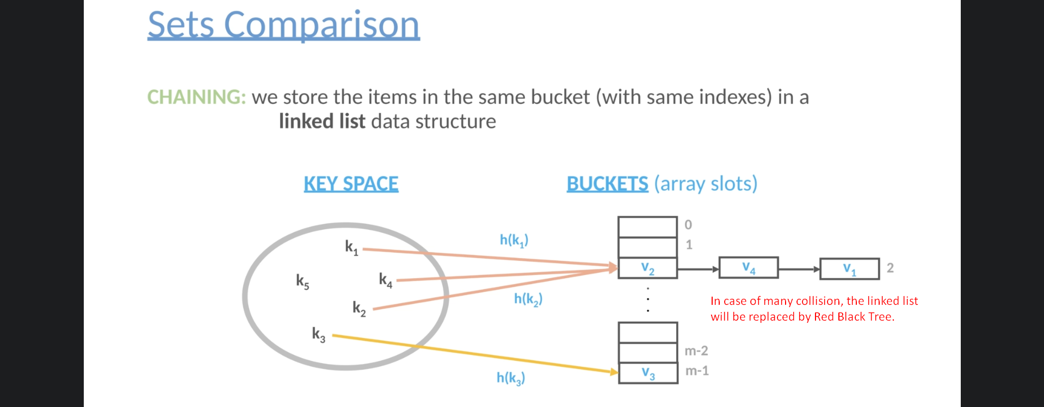
4. 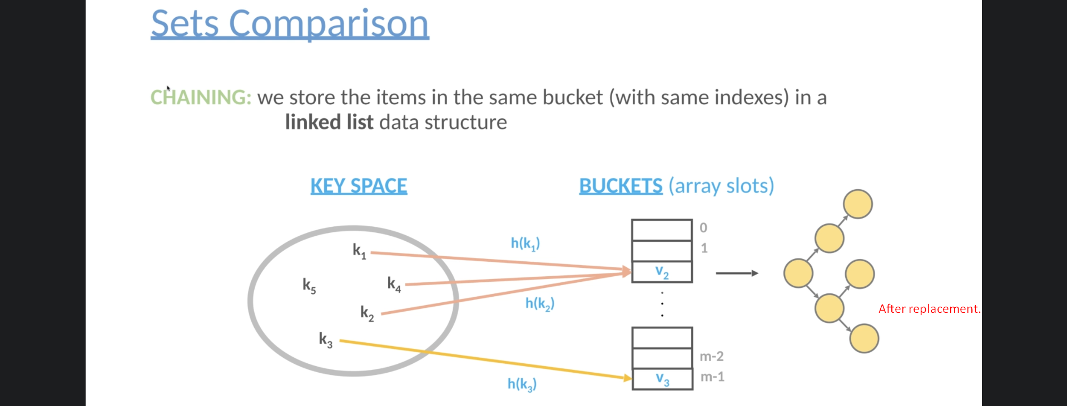
5. 